
Student's name: Hua Tan Kiet.
Student's ID: GCS18671.
Student group: TCS2209.
Instructor: Ho Nguyen Phu Bao.
Course: Proposal Project Final
Campus/Programme: TOP-UP SE.

Undergraduate Final Year Project Proposal
PROJECT PROPOSAL
[Game 2D Adventure]
[Hua Tan Kiet]
[Final Project]
[COMP 1682]
Table of Contents
1. Overview 4
1. Aim. 5
2. Objectives 6
3. Legal, Social, Ethical and Professional 7
4. Planning. 8
5. Initial References 8
Reference 11

Table of Figure
Figure 1: Gant Chart Final Project 1. 8
Figure 2: Gant Chart Final Project 2. 8
Figure 3: Gant Chart Final Project 3. 9

Overview
Vietnam, like many other countries with increasing population density, also experiences a growing demand for entertainment. This trend has led to the rise of entertainment applications and gaming platforms, with the latter being the most popular. It is estimated that the gaming industry in Vietnam will be worth $136 million in 2021. (Indra Overland 10 December 2020) In this report, we will discuss the game market's status in Vietnam, explore the rising trends in game genres, and introduce our plan to design a game using Unity engine.
Vietnam has the highest average weekly entertainment electronic hours, with approximately 9 hours per week. This statistic confirms that Vietnam is the leading market in Asia regarding game usage, higher than the global average. The gaming industry is a lucrative market in Vietnam and shows no sign of slowing down. Consequently, it presents a promising opportunity for newcomers to learn and develop games. (Nguyen 31 July 2003)
The gaming trends in Vietnam are changing, with adventure games and puzzles gaining popularity. Our desire to create a game product that would enthrals the players and strengthen our motivation to work towards the project further led us to design a game using Unity engine. (MAGO November 2020)
Unity is a cross-platform game engine that is extensively used to develop video games for various platforms like computers, tablets, laptops, and smartphones. Unity's free edition is attractive to many developers. Unity Editor does not require coding to arrange objects in the game. Developers can drag and drop and change each object's position in-game directly on the Editor. The cross-platform feature of Unity makes it easier to run games on various operating systems like Desktop (Mac, Window, and Linux), Mobile (iOS, Android), and Web (WebGL). For character designing, we plan to use the C++, C#, and Unity Script language, as they are well-supported by Unity engine, especially Unity Script, as revealed in internal testing. The game's music will be licensed and done by us using some free software. (Skyttä 2018)
The game industry is flourishing in Vietnam, and adventure games and puzzles are gaining popularity. We have outlined our plan to design a game product that will satisfy the players' expectations using Unity engine, which is the preferred game engine for many developers. We believe the game will be unique and enthralling to the users.

Aim.
In the process of implementing a game project, it is crucial to clearly define the goals. In this project, the two primary goals are developing a fantastic game product and gaining valuable lessons and experiences throughout the development process. The objective of this report is to outline the process used in creating an action-adventure entertainment game that aims to bring enjoyment and entertainment to gamers after a week of hard work and study. The game will be a 2D adventure game using the latest technology and techniques to provide users with the easiest and most exciting gameplay experience.
The project has two main goals. The first objective is to develop an excellent game product that will entertain and provide enjoyment to users. This goal is crucial since the gaming industry in Vietnam is booming, and the demand for quality entertainment games is increasing. To achieve this, we aim to create a 2D adventure game that is packed with exciting features and gameplay, making it one of the most interesting and engaging games available on the market.
The second goal is to learn and acquire valuable experience throughout the project's development process. Since technology is constantly evolving, there is a need to keep up with it, and the development of this game will provide an excellent opportunity to learn and explore new techniques and technologies.
For this project, we plan to develop an action-packed 2D adventure game using the latest technology and techniques. The game will incorporate an engaging storyline, stunning graphics, and captivating sound effects to provide the players with a thrilling gaming experience. The primary objective is to make the gameplay as easy and enjoyable as possible for gamers.
The development of a game project requires clear goals for accomplishing the desired outcomes. In this project, the two primary goals are developing an excellent game product and gaining valuable experience during the development process. The game's design focuses on creating an action-packed 2D adventure game using the latest technology and techniques, aiming to make the gameplay experience easy and enjoyable for all gamers.

Objectives
- Project planning
1.1. Present the project to the lecturer
1.2. Provide a solution for the project
1.3. Edit for the project
1.4. Show estimated time
1.5. Determine the delivery time
1.6. Timeline for the project
- Knowledge for the project
2.1. Learn basic C# programming language
2.2. Study 2D games
2.3. Learn some games in Unity
2.4. Learn about artificial intelligence (AI)
2.5. Learn the unified scripting language
2.6. Learn about Unity Engines animations
2.7. Learn about the right character for the Game
2.8. Character Animation / NPC Unity Tool
2.9. Background Design in Unity Engines
2.10. Designing maps in Unity Engines
2.11. Event Research in Unity Engines
2.12. Learn sound effects
2.13. Camera follows the character
2.14. Learn about different items and traps
- Game project development
3.1. Forming ideas and rules of the game
3.2. Skill design for game characters
3.3. Character Building / NPC
3.4. Character animation/motion design
3.5. Interface design for games
3.6. Game mode design for the game
3.7. Map design for the game
3.8. Start testing the game
3.9. Check and fix errors
3.10. Evaluate errors and provide solutions
3.11. Write a report
- Market survey
4.1. Allow users to experience the game trial
4.2. Lessons learned for the project
4.3. Final edit of the project
4.4. Test game again
4.5. Release the official version of the game
- Final Report
5.1. Write a report for the lecturer
5.2. Upload final report

Legal, Social, Ethical and Professional
Legal:
- Unity Technologies is the creator of the multi-platform game engine called Unity, which supports 2D and 3D graphics and programming languages such as C#, Boo, and Unity Script. The primary function of this software is the development of video games for various devices, including computers, consoles, and smartphones.
- In accordance with ethical standards, all references utilized in this project will originate from legal sources, including licensed materials or legally obtained copies. Where applicable, free sources will also be utilized while adhering to the terms of use.
- The Final Project is owned by me and in conjunction with the University of Greenwich.
Social:
- The primary purpose of the game being developed is to serve as an entertaining activity for individuals following a long day at work, appealing to a wide range of players. Additionally, the project serves as an opportunity for the researcher to garner more experience in the game development industry.
- The game being developed centres around various forms of law enforcement, with no relation to social misconduct or corruption.
Ethical:
- The ultimate goal of the final project was to refine and enhance my skillset in the area of study.
- It is guaranteed that the project is completely free of plagiarism.
- All sources that have been referenced, including those obtained from documents or online platforms, as well as any licensed materials from websites, have been appropriately and clearly cited.
Professional:
- Confidentiality of information obtained during the project will be maintained and not be used for personal gain or disclosed to third parties unless authorized by the University of Greenwich or required by State Law.
- We will respect and consider alternative perspectives, while accepting and utilizing honest feedback and criticism to enhance the final project.
- In order to avoid any conflict of interest between us and governing authorities, we will refrain from any potentially compromising circumstances.

Planning.
Project planner in MS Project format is used to track project progress (Appendix A).

Initial References

Appendix A – Project of schedule
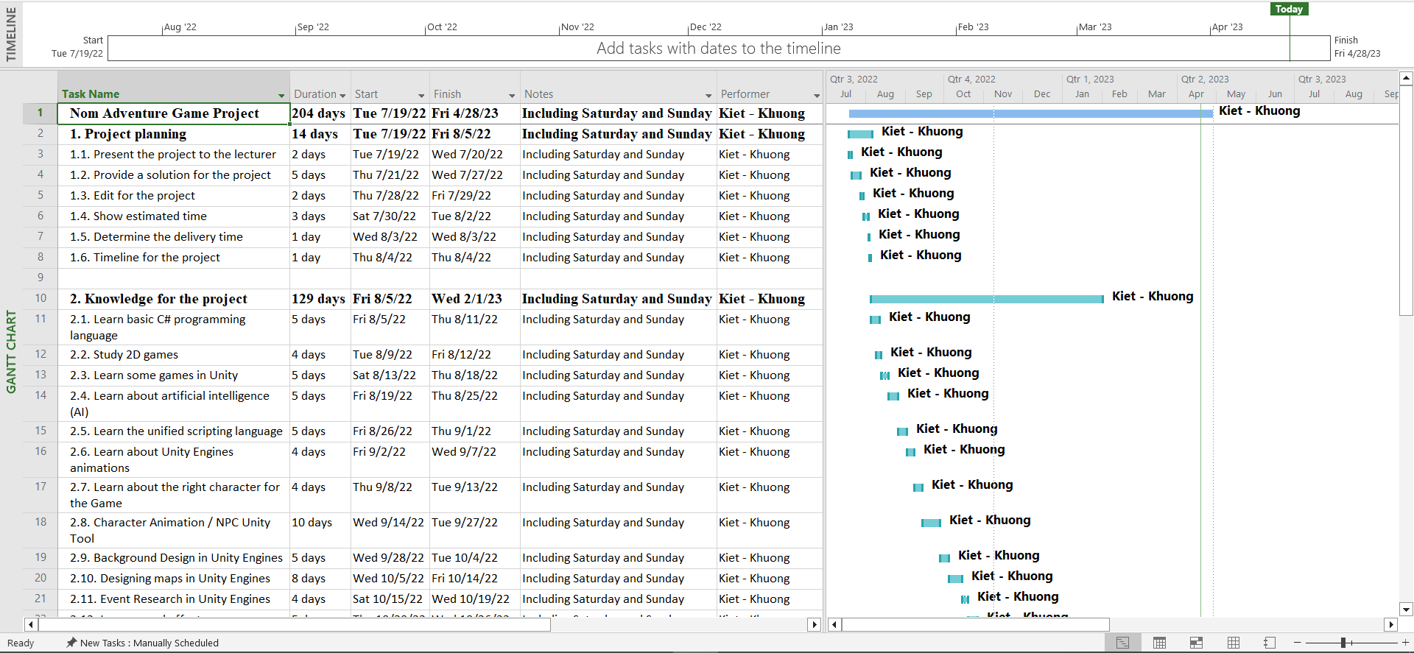
Figure 1: Gant Chart Final Project 1.

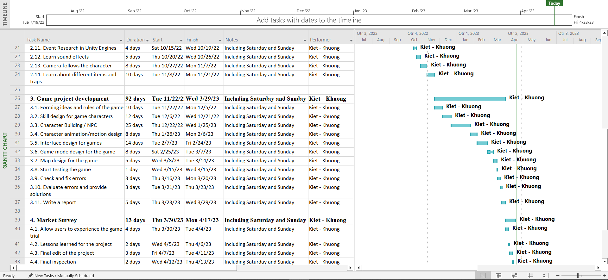
Figure 2: Gant Chart Final Project 2.

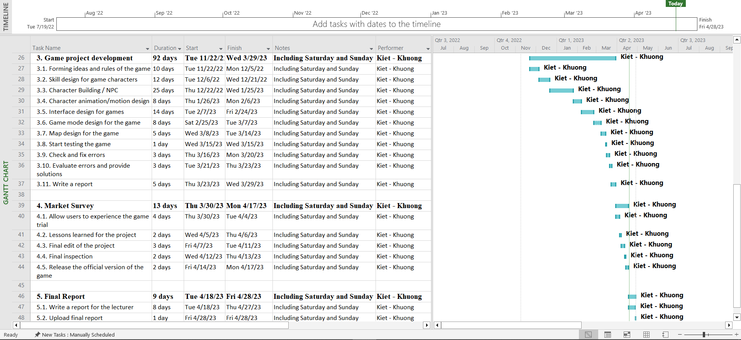
Figure 3: Gant Chart Final Project 3.

Reference
Indra Overland, H. F. S., Hoy-Yen Chan, Monika Merdekawati, Beni Suryadi, Nuki Agya Utama, Roman Vakulchuk (10 December 2020). The ASEAN climate and energy paradox.

MAGO, Z. (November 2020). Communication Today.

Nguyen, A. (31 July 2003). The current status and potential development of online news consumption: A structural approach.

Skyttä, R. (2018). CROSS-PLATFORM GAME DEVELOPMENT.

